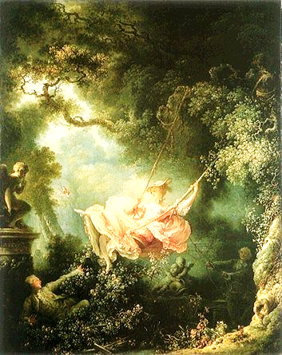**Literary Arts 9**

**Rococo and Romantic Periods**

Rococo (Regency period in England) - (Gone are the great religious and Classical themes of Baroque.)

Context: Revolution and “The Enlightenment”

Stylistic Characteristics: Luxurious, frivolous, sensual, clever, witty, colorful, asymmetrical, decorative-- Plant and scroll motifs, charming scenes of carefree pleasure.

Some important artists:

Watteau, Boucher, Fragonard, Hogarth, Gainsborough

Terms:

The French Academy

Pastels

Folk Art

***The Tradition***

**Romanticism** (*began as a literary movement*)

A very expansive and inconsistent style….a shift from calculation to intuition ……

Has 3 components:

Neo-Classicism (1750-1800)

* *Characteristics:* (based in the discoveries of Pompeii and Herculaneum) serious, moral, heroic, severe, sober, rational, removed in time and space, civic idealism, self-sacrifice
* *Subjects:* Mythology, Ancient History, Nature as it “should be”

Romanticism (1800-1840)

* *Characteristics:* incorporates the “sublime”, sentimental, sincere feelings, The “Gothick” or Gothic, interest in past times, exotic, illogical, emotional, colorful

Realism (1840-2017?)

Some Artists:

Benjamin West… (@ CW)

Gilbert Stuart…(@ CW)

Charles Wilson Peale (@ CW)

David

Blake

Thomas Jefferson

Nash

Terms:

1. Revivals
2. The SUBLIME – to experience life to the fullest-awe and terror (the terrible seen from a safe distance can be exciting) – Nature can be part of the sublime.
3. The Gothic (sublime and history mix)—includes interest in the fantastic, occult, grotesque, macabre

**More Romanticism: (19th century)**

**Concepts:** art as propaganda & artists without patrons

**Some Artists:**

Daumier

Goya

Gericault

Delacroix

Ingres

Turner

**Terms:**

Oil sketch

Hudson River School

Lithograph

Poster

View paintings

**(Second Half of the Nineteenth Century)**

**Context:** Marx, Dickens, Wordsworth

**Terms:**

Realism: *Man has, throughout time, produced “real” art – now the issue is that the subject must be visible and of the current time.*

Barbizon School

Pre-Raphaelites

Impressionism:

* Characteristics – colored shadows, the effects of light on color, forms dissolve in light, optical mix, divided brush strokes.
* Technology and Impressionism – camera, metal neck of brush, metal paint tube, palette of colors.

Post-Impressionism

Divisionism

Symbolism: (passion, visionary - Romantic)

**Some Artists:**

Courbet

Homer

Sargent

Manet

Degas

Seurat

Van Gogh

Gauguin

Toulouse-Lautrec

Cassatt

Cezanne

Munch

Rodin

Eiffel

Renoir

Monet

Eakins

|  |  |  |
| --- | --- | --- |
| **ARTIST** | **WORK** | **NOTES** |
| Blake | Ancient of Days |  |
| Boucher | Cupid a Captive |  |
| Cassatt | The Boating Party |  |
| Cezanne | Still Life with Peppermint Bottle |  |
| Courbet | Burial at Ornans |  |
| Daumier | Rue Transnonain |  |
| David | The Death of Socrates |  |
| Degas | The Glass of Absinthe |  |
| Delacroix | The Lion Hunt |  |
| Eakins | The Gross Clinic |  |
| Eiffel | Eiffel Tower |  |
| Fragonard | The Swing |  |
| Gainsborough | Jonathan Buttle |  |
| Gauguin | Spirit of the Dead Watching |  |
| Gericault | The Raft of the Medusa |  |
| Goya | The Third of May |  |
| Hogarth | Marriage a la Mode |  |
| Homer | The Fog Warning |  |
| Ingres | Grande Odalisque |  |
| Manet | Dejeuner sur L’Herb |  |
| Monet | Rouen Cathedral, Full Sun |  |
| Munch | The Scream |  |
| Nash | Royal Pavilion |  |
| Renoir | Moulin de la Galette |  |
| Rodin | The Burgers of Calais |  |
| Sargent | The Daughters of Edward Darley Boit |  |
| Seurat | Sunday on La Grande Jatte |  |
| Toulouse-Lautrec | At the Moulin Rouge |  |
| Turner | Slave Ship |  |
| Van Gogh | Starry Night |  |
| Watteau | Embarkation for Cythera |  |
| West | The Death of General Wolfe |  |