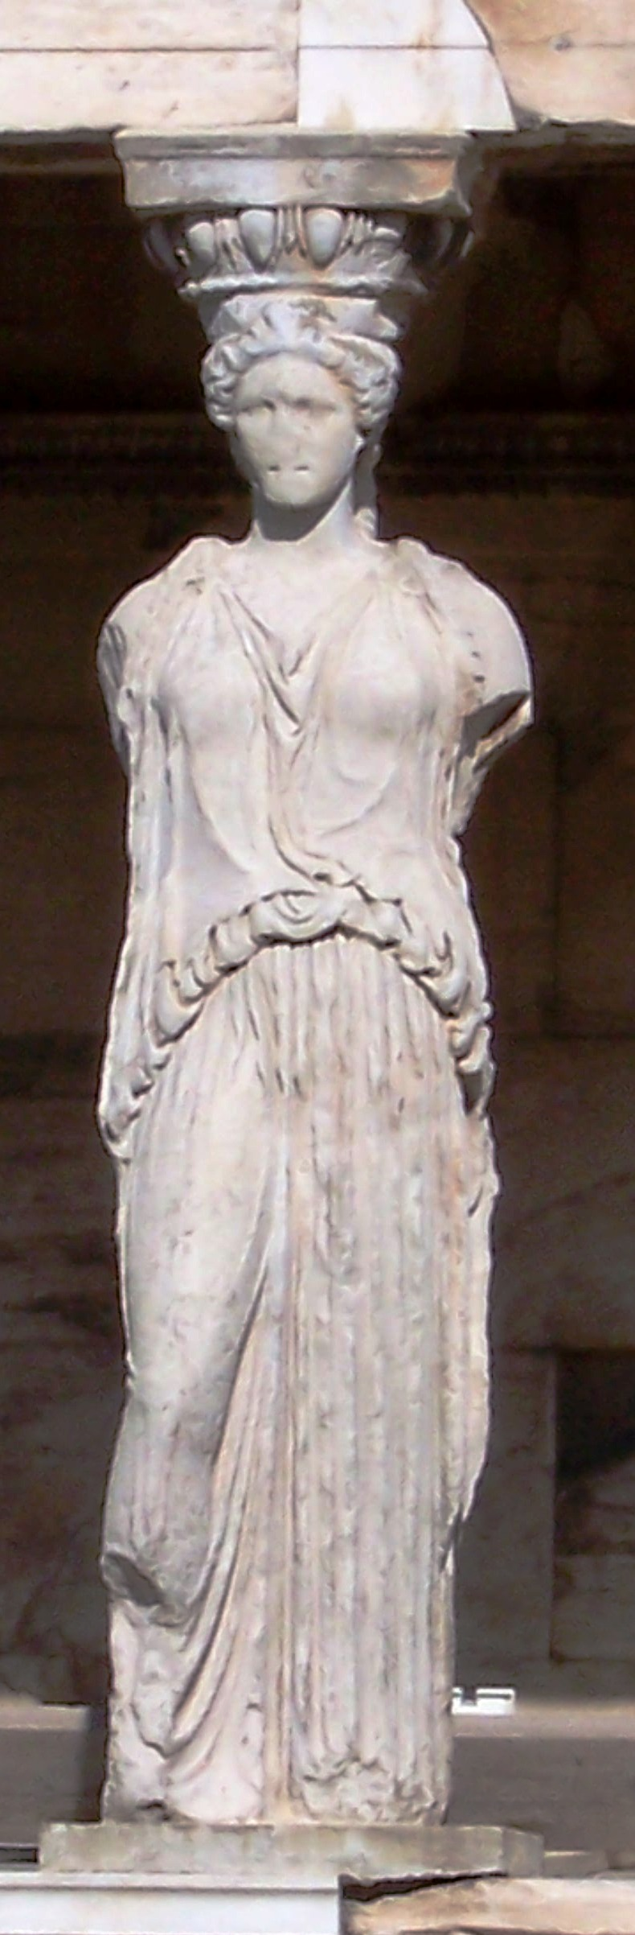Literary Arts 9
Greek Art DVG

CENTRAL QUESTIONS
- What philosophical and visual differences between Egyptian and Greek sculpture?
- What is contrapposto, and why is it significant?
- What are the major components of the Greek temple? How did the temple function?
- Tell about Greek pottery (types, materials, artists etc.) and why study of it is of value to historians.
- What are the Elgin marbles, and why are they important today?
- Where have you seen the application of Greek Architecture in the U.S.?

PERIODS/CHARACTERISTICS (Dates for reference… not memorization!)
Geometric Period (900-700 BCE) Homer = Iliad & Odyssey
Archaic Period (700-480 BCE) sculpture = limited movement, frontal, archaic smile, formal, concerned with indicating movement and naturalism
Orientalizing Phase of Archaic Period (730-650 BCE) zoomorphic, curvilinear, monsters, action
Transitional Period (500-400 BCE) sculpture = naturalistic depiction of movement; mask of beauty = immobile expressions
Classical Period (450-323 BCE) Plato; sculpture = interest in portraying females; Phidian Style – figures show balance and mastery of movement, graceful
Hellenistic Period (323-30 BCE) sculpture = a wide range of human types of all ages and conditions (realism) depicted; acceptable to show death, pain, states of mind, drama, trivia, pathos

CONCEPTS:
- Idealistic, Naturalistic, Realistic
- Greek gods look like men and women
- Problem with the pediment
- Order, rationality, logic

TERMS

Acropolis
Amphora
Black Figured Style
Column
Contrapposto
Corinthian
Doric
Entablature
Foreshortening
Frieze

Hollow Cast Sculpture
Ionic
Krater
Kylix
Order
Parthenon
Pediment
Red Figured Style
Solid Cast Sculpture
Zoomorphic

Major Greek Vase Shapes (There are many more!)
Factoid: the Greeks wrote on a wooden tablet coated in wax – erasing would be done easily with a little application of heat- more permanent records were then transferred to a papyrus – beginning in the 2nd century BCE a crude parchment was used.

Vases used for storing and transporting wine and foodstuffs
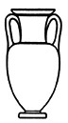 | Amphora was a two-handled vase used for storage and transport.
Vases used for mixing and cooling wine
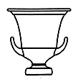 | Krater means “mixing-bowl,” and the vase was used for mixing wine with water. (The Greeks did not drink their wine “neat”.)
Vases used for drinking or pouring (wine or water)
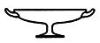 | Kylix This drinking-cup is sometimes called the “symposium-vase,” since it appears often in vase-representations of symposia.
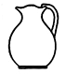 | Oinochoe This vase is a kind of ladle or small pitcher used for pouring wine from the krater into a drinking-cup. The word oinochoe means “wine-pourer.”
Vases used for drawing water

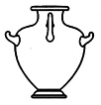 | Hydria The name of this three-handled vase is derived from the Greek word for water. Hydriai were used for drawing water, as ballot-boxes, and also as urns to hold the ashes of the dead. They are commonly seen in vase-representations of women drawing water at the fountain-house.
Vases used for cosmetics
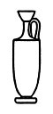 | Lekythos This vase was a flask used for toilet oils, perfume, or condiments, and also appears in funerary contexts, where it was used to pour libations for the dead or was left on the grave as an offering.

Work | Period | Notes
Dipylon Krater | Geometric
Ajax and Achilles Playing Dice | Archaic
Calf Bearer | Archaic
Kritios Boy | Classical
Discobolus (by Myron) | Classical
Dying Gaul | Hellenistic
Nike of Samothrace | Hellenistic
Seated Boxer | Hellenistic
Venus de Milo | Hellenistic

