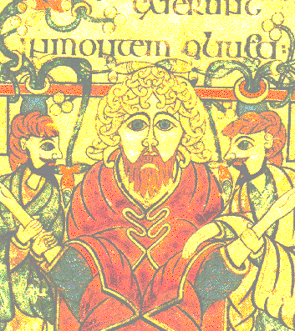**Literary Arts 9**

**EARLY MIDDLE AGES**

**Art DVG**

* Could you explain how an *Illuminated Manuscript* page is made?
* How did Pope Gregory help make visual art acceptable to Christians?

**Early Medieval Art –** About 500 CE – not the void historians first believed

Rise of Feudalism – Barbarian and Pagan kings

**Pagan Art**

*Interlace patterns*

*Animal style* (*zoomorphic* forms)

“Nomads gear” & Utilitarian art

Metal work includes *Cloisonné*

**Christian Art**

Must illustrate for the illiterate

*Vellum* and *parchment*

Illuminated Manuscripts (*Gospel, Psalter* etc.)

*Scriptorium*

Mirror images

Symmetrical

**Carolingian Style** - 800 CE (the end of the “dark ages”)

Charlemagne

|  |
| --- |
| Work |
| 1. Portal of a Stave Church |
| 2. Book of Lindisfarne |
| 3. Celtic Cross (High Cross of Muiredach) |
| 4. Palatine Chapel (interior) 800 CE |
| 5. St. Matthew from the Ebbo Gospels 800 CE |
| 6. Doors from Saint Michaels, Hildesheim |

*West works*

*Bay* system